Déjà vu
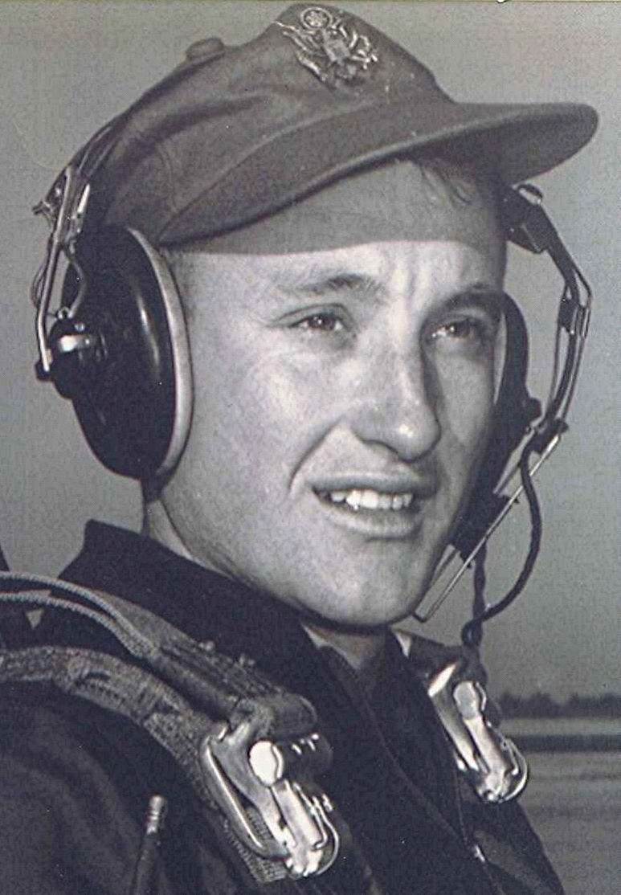
Where are they now?
October 1997
The above photo was taken during the senior trip to Petit Jean Mountain, May 1951. In the foreground, Joye Ruth Robbins and Boyd Dodson. In the background are Mary Sue Young and Lynn Fite. Whatever happened to these folks, in some cases, remains a mystery. It is reported that Boyd was last seen in an obscure third world country, forming a squadron of mercenary pilots who hoped to overthrow the local government.
Lynn, after graduating with a degree in geology, led an expedition of five into the trackless jungles of South America. That was the last ever heard of him and his party, except rumors that he had become enamored of the tribal culture and elected to stay in that part of the world, untouched by technology. It is also believed that he was appointed "Grand Poobah" and Most excellent and tall warrior for his expertise in firing a poisoned dart blowgun. Occasionally, jungle artifacts with no return address are delivered by UPS to the homes of former classmates.
Joye Ruth went on to become one of the top dancers at Radio City. When that review closed she returned to Sparkman and taught modem dance interpretation at the local high school until her retirement a few years ago.. Her talents are much in demand, as she tours with her dance group of seniors known as the "Blue-Haired Rockettes." They have performed their supp-hose review before such groups as the Fordyce Rotary Club and the Bearden senior citizens bingo club.
Mary Sue followed her inclinations to be in the limelight of the political world by moving to Washington, D.C., where she became a special advisor to the Ambassador to Upper Volta. Her travels have taken her to many exotic places on the African continent, including Addis Ababa, Ethiopia, and Wheelus, Libya, where she purchased a partnership in a rug exporting firm. Last reported to have been seen on a small private island in the Caribbean, which, it is rumored, she has purchased for her retirement home.

